Name
Address | 413-415 Swan Street, Richmond | Extent of Overlay  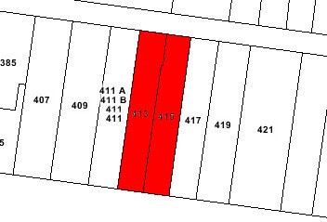
Place Type | Pair of shop/residences
Survey Date | April 2012 (external inspection only)
Date of Construction | 1892
Recommendation | Include in the Schedule to the Heritage Overlay (Individually significant)

Intactness |  | Good | x | Fair |  | Poor

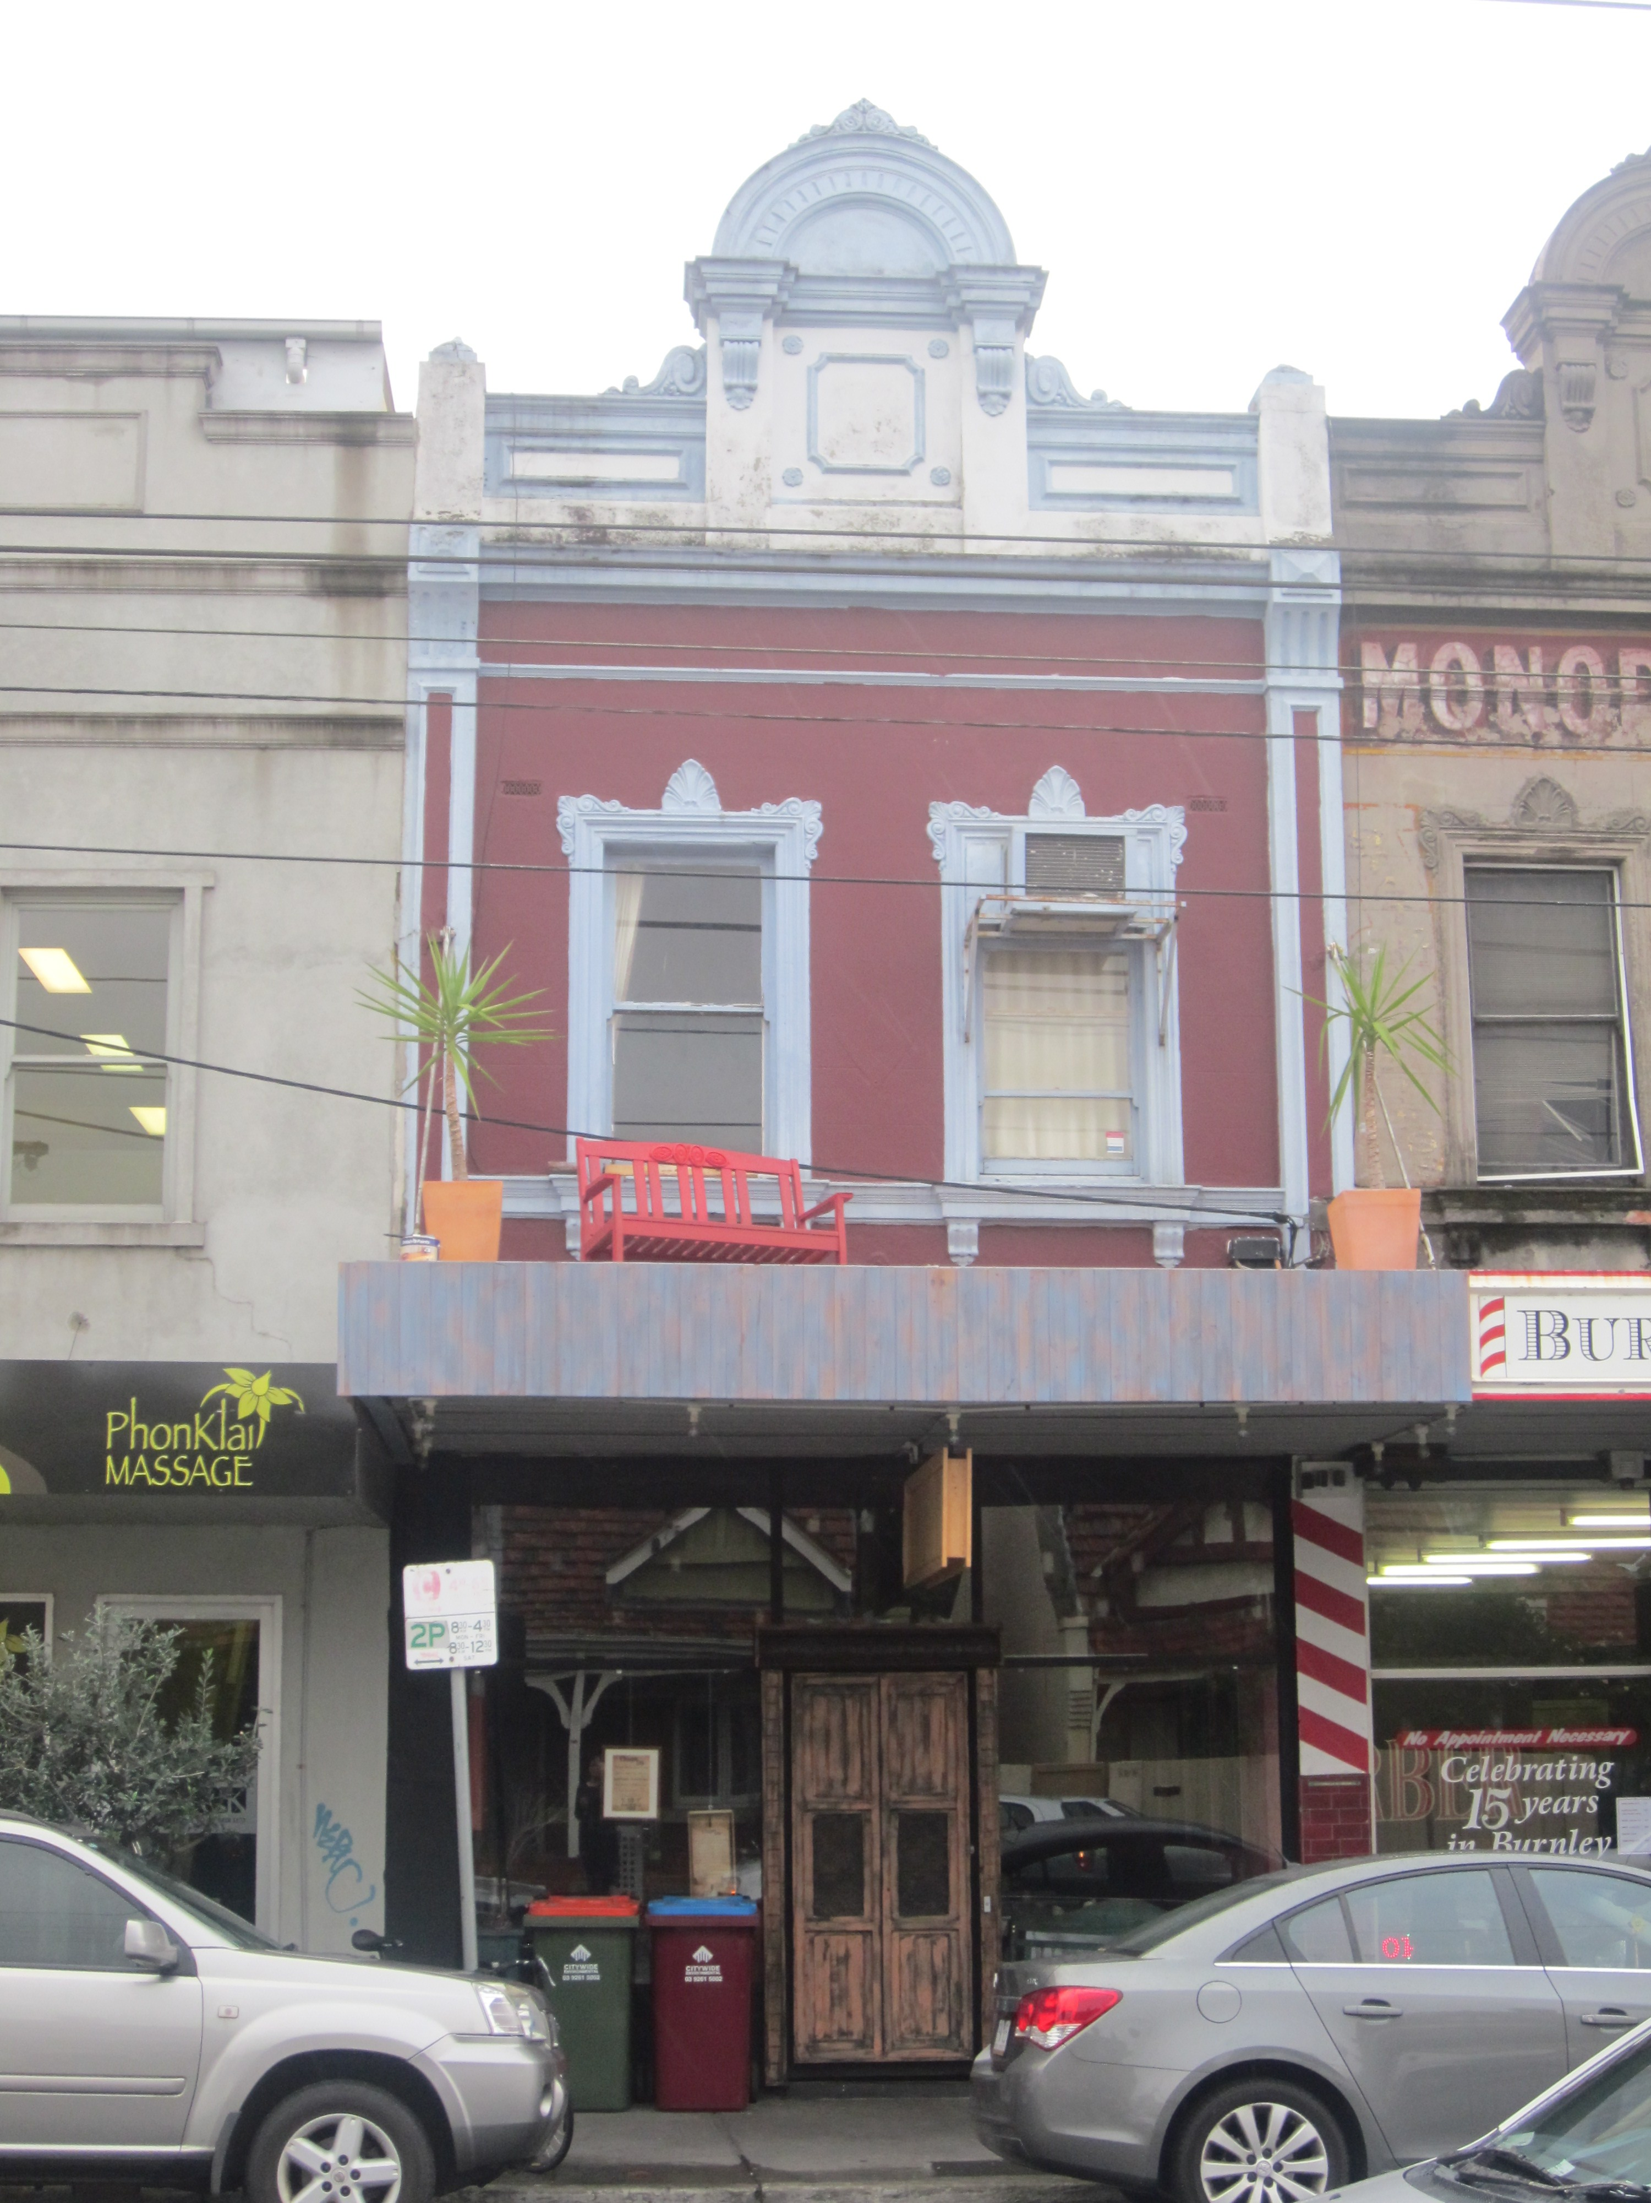
No. 413 Swan Street at left, and no. 415 Swan Street at right.

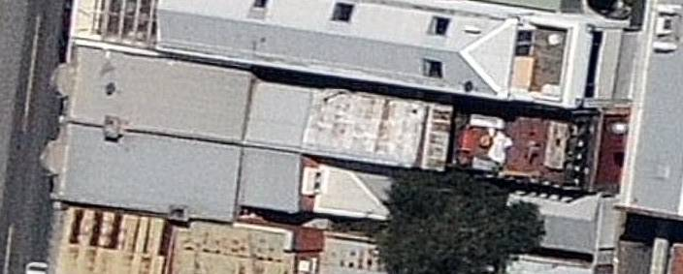
Recent aerial photograph of the subject properties showing the later additions to the rear.
Source: Nearmap (12 March, 2012).
From left: View of the moulded detailing to the parapet of no. 413; detail of the unpainted architrave to the west window of no. 415, and section of early signage above.

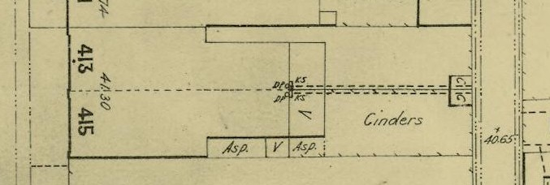
Section of the MMBW plan no. 1096 dated 1901 showing the building envelope at this date.
Source: State Library of Victoria.

History
In 1838-9, eighty-eight allotments in what became the suburbs of Fitzroy, Collingwood and Richmond were made available as part the first land sales outside of the town reserve of Melbourne. In the early 1850s, reserves were created for recreation, police purposes, a produce market, schools and a mechanics’ institute, with a separate municipality of Richmond created in 1855. Early development in Richmond was concentrated in the north and west of the suburb, with the eastern part of the suburb remaining largely undeveloped. In this period, retail trade and services were first established in Swan Street and Bridge Road. Although initially viewed a gentlemen’s retreat suburb in the 1840s, Richmond came to be characterised as a working class suburb, particularly following the population boom which came after the 1850s gold rushes. Development increased in the suburb during the 1870s and 1880s, as was the case in much of Melbourne. The eastern part of Richmond, where the subject property is located, was partially subdivided by 1874, and by 1888, most of the street layout was complete.

Swan Street was designated as a road reserve in 1837, and was reputedly named after the (then) Swan Inn, at the corner of Church Street. Allotments along the road reserve were sold from the late 1830s, but more intensive subdivision of the area adjacent to the road, at least for the western end of Swan Street (east of Punt Road), did not occur until the 1850s. By the 1880s, the street had started to assume some of the character it retains today, with a concentration of buildings, including commercial buildings, around the intersection with Church Street. Swan Street originally terminated at the Survey Paddock (now Burnley Park), but was extended to the Yarra River in the 1880s. The Wallen Road Bridge, which connected Richmond to Hawthorn, was built in 1881. The road was sealed in 1901; and the electric tram service was introduced in 1916.

Swan Street in the 1880s was a well established retail and service precinct. By 1889, the block between Burnley and Cutter streets had a chemist, butcher, fruiterer and an outlet of the Moran & Cato chain of grocery shops. In 1892, J. Wood, a carpenter, erected the subject building, being a pair of two-storey brick shops and combined residences at 413 and 415 Swan Street. This was in the period of the severe economic Depression of the early 1890s.

No. 413 was of four rooms, and rated with a net annual value of £26; while no. 415 was of six rooms, and rated at £30. In 1895, no. 413 was occupied by Mrs J Walker, who sold dairy produce, and from 1914 into the 1970s a fruit shop was operating from the premises. Carpenter and greengrocer, George Betts initially occupied no. 415, but by 1895, M Wills, a butcher, was in occupation and remained at the premises until at least 1910. Rupert Conroy had established a hairdresser and tobacconist business by 1921, and the extant ‘Monopole Magnum Cigars’ sign on the first floor façade of no. 215 is likely to date from this use. W Higginbotham was operating the tobacconists and hairdressers by 1924, and the use of this shop as a hairdressing salon continued at least into 1970s.

Victoria’s Framework of Historical Themes
Theme 5: Building Victoria’s industries and workforce; sub-theme 5.3: Marketing and retailing.

Description & Integrity
The properties at nos 413-415 on the north side of Swan Street, Richmond, are a Victorian two storey brick terrace pair of shops with combined residences. They both have skillion roof forms clad in galvanised corrugated steel, concealed by a prominent arched pedimented parapet on the south façade. The first floor facades are rendered and no. 413 has been overpainted, while no. 415 has, unusually, remained unpainted (save for the ‘Monopole Magnum Cigars’ sign). Window architraves, brackets, supporting stringcourse and mouldings remain intact at first floor level to both terraces, as do the parapets incorporating panels, brackets, cornices and mouldings, urn pedestals and dividers. The property dividers are coffered piers topped by triglyph modillions supporting the main cornices. No. 413 has a long-standing ‘Monopole Magnum Cigars’ sign (believed to date from the 1920s, see ‘History’ above). Minor spalling is evident on no.415’s facade and there may have been finials at the upper level that have since been removed. Both have pairs of double-hung sash windows, with original timber framing; the windows to no. 415 have been fitted with insect screens and there is an air-conditioning unit fitted to the east window of no. 413. The awnings are non-original although the steel rods supporting the awning to no. 415 suggest that it dates from the early twentieth century. The ground floor shop fronts have largely been altered, no. 313 in recent years and no. 415 possibly in the 1960s, although the maroon tiling on the end walls may be earlier.

Recent aerial photographs indicate that the buildings have been extended to the rear. No. 413 is built to the rear boundary with a brick garage to the lane, enclosed on the upper level with an iron balustrade creating a large balcony. There is a single storey gable roof shed clad in steel sheeting to the rear lane at no. 415. The rear elements are not of heritage significance.

Comparative Analysis
Nos 413-415 Swan Street, Richmond is a well-preserved pair of Victorian two storey terraced brick shops and residences. The pair is broadly consistent with many nineteenth century two-storey shop and house combinations, in inner suburban main road locations, including having modified ground floor shopfront components. The first floor to the pair retains its original form and detailing. In particular, the upper level façade to no. 415 has, unusually, remained unpainted; this façade is further distinguished through the retention of the ‘Monopole Magnum Cigars’ sign. Both first floors also have prominent and well-detailed arched pedimented parapets.

Assessment Against Criteria
Amended Heritage Victoria Criteria – Criteria adopted by the Heritage Council on 7 August 2008 pursuant to Sections 8(1)(c) and 8(2) of the Heritage Act 1995.

Criterion A - Importance to the course, or pattern, of the City of Yarra’s cultural history.

Nos 413-415 Swan Street, Richmond is of local historical significance. The pair of two storey brick shops and combined residences was constructed in 1892 for carpenter, J. Wood. This was just after the period when commercial development consolidated in Swan Street and, unusually, during the severe economic Depression of the early 1890s. The buildings were subsequently occupied by a range of retailers and commercial operations, typical for a main street of the late nineteenth and early twentieth century. These included sellers of dairy produce, a greengrocer, butcher, hairdresser and tobacconist.

Criterion B - Possession of uncommon, rare or endangered aspects of the City of Yarra’s cultural history.

N/A

Criterion C - Potential to yield information that will contribute to an understanding of the City of Yarra’s cultural history.

N/A

Criterion D - Importance in demonstrating the principal characteristics of a class of cultural places and objects.

N/A

Criterion E - Importance in exhibiting particular aesthetic characteristics.

Nos 413-415 Swan Street, Richmond is of local aesthetic/architectural significance, as a well-preserved pair of Victorian two storey brick shops and residences. The pair is broadly consistent with many nineteenth century two-storey shop and house combinations, in inner suburban main road locations, including having modified ground floor shopfront components. However, the first floor facades retain their original form and detailing; in particular, the upper level façade to no. 415 has remained unpainted. This façade is further distinguished through the retention of the ‘Monopole Magnum Cigars’ sign. Both first floors also have prominent and well-detailed arched pedimented parapets.

Criterion F - Importance in demonstrating a high degree of creative or technical achievement at a particular period.

N/A

Criterion G - Strong or special association with a particular community or cultural group for social, cultural or spiritual reasons. This includes the significance of a place to Indigenous peoples as part of their continuing and developing cultural traditions.

N/A

Criterion H - Special association with the life or works of a person, or group of persons, of importance in City of Yarra’s history.

N/A

Statement of Significance
What is significant?
Nos 413-415 Swan Street, Richmond is a Victorian two storey brick terrace pair of shops and combined residences. The ground floor shopfronts have been modified, but the rendered first floor facades are intact, with no. 413 remaining unpainted save for the c.1920s ‘Monopole Magnum Cigars’ sign. Intact details include double-hung sash windows, window architraves, brackets, supporting stringcourse and mouldings, plus pedimented parapets incorporating panels, brackets, cornices and mouldings, urn pedestals and dividers. The buildings have been extended to the rear; these later elements are not of heritage significance.

How is it significant?
Nos 413-415 Swan Street, Richmond is of local historical and aesthetic/architectural significance.

Why is it significant?
Nos 413-415 Swan Street is of local historical significance, as a pair of two storey brick shops and combined residences constructed for carpenter, J Wood in 1892. This was just after the period of commercial development consolidation in Swan Street, and unusually during the severe economic Depression of the early 1890s. The buildings were subsequently occupied by a range of retailers and commercial operations, typical for a main street of the late nineteenth and early twentieth century. These included sellers of dairy produce, a greengrocer, butcher, hairdresser and tobacconist. The subject property is also of local aesthetic/architectural significance. It is a well-preserved pair of two storey shops/residences, broadly consistent with many similar nineteenth century commercial buildings in inner suburban main road locations. However, the first floor facades retain their original form and detailing; in particular, the upper level to no. 415 has remained unpainted. This façade is further distinguished through the retention of the ‘Monopole Magnum Cigars’ sign. Both first floors also have prominent and well-detailed arched pedimented parapets.

External paint colours | Yes
Internal Alterations Controls | No
Tree Controls | No
Outbuildings and fences not exempt | No
Victorian Heritage Register | No
Prohibited uses may be permitted | No
Incorporated plan | No
Aboriginal heritage place | No

References

Allom Lovell & Associates, Fitzroy Urban Conservation Study Review 1992, Thematic History, p 4.1.
O'Connor, John et al, Richmond Conservation Study, Volume 1, 1985, p. 11.
Map of Melbourne and its suburbs, 1855, Lands Department map, surveyed by James Kearney.
O'Connor, John et al, Richmond Conservation Study, Volume 1, 1985, p. 11.
Copping it Sweet: Shared Memories of Richmond, City of Richmond and Carringbush Regional Library, 1988, p. 5.
O'Connor, John et al, Richmond Conservation Study, Volume 1, 1985, p. 12.
City of Yarra Heritage Review, Vol. 3 Review of Heritage Overlay Precincts, Allom Lovell & Associates, 1998, p.155.
Sands and McDougall Melbourne and suburban directory, 1889.
City of Richmond rate books, East Ward, 1892-94.
Sands and McDougall Melbourne and suburban directory, 1894-1974.
Sands and McDougall Melbourne and suburban directory, 1894-1974.

